Yichen Dong HW 9

Yichen Dong

November 1, 2018

## Problem 1

stomach = c(25,42,45,46,51,103,124,146,340,396,412,876,1112)  
breast = c(24,40,719,727,791,1166,1235,1581,1804,3460,3808)  
log_stomach = log(stomach)  
log_breast = log(breast)  
mean_log_stomach = mean(log_stomach)  
mean_log_breast = mean(log_breast)  
  
b = 10000  
bootstrap_theta_st = NULL  
for(i in 1:b){  
 n = length(stomach)  
 data_bootstrap = sample(log_stomach,size = n, replace = TRUE)  
 bootstrap_mean = mean(data_bootstrap)  
 bootstrap_theta_st[i] = bootstrap_mean  
}  
bootstrap_theta_bar_st = mean(bootstrap_theta_st)  
bootstrap_variance_st = 1/(b-1)*sum((bootstrap_theta_st-bootstrap_theta_bar_st)^2)  
#Finding the CI using an alpha of .05 and using the Percentile Method  
sorted_bootstrap_theta_st = sort(bootstrap_theta_st)  
bootstrap_theta_CI_st = c(bootstrap_theta_bar_st- sqrt(bootstrap_variance_st)*qnorm(.975),bootstrap_theta_bar_st +sqrt(bootstrap_variance_st)*qnorm(.975))  
bootstrap_theta_CI_st_pct = c(sorted_bootstrap_theta_st[round(b*.025)],sorted_bootstrap_theta_st[round(b*.975)])  
bootstrap_variance_st

## [1] 0.1088757

hist(bootstrap_theta_st)

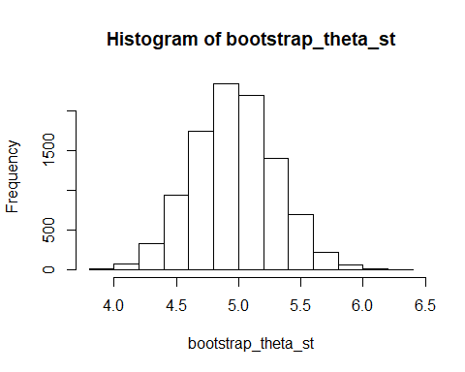

bootstrap_theta_CI_st

## [1] 4.319724 5.613156

bootstrap_theta_CI_st_pct

## [1] 4.330936 5.623129

#For breasts  
b = 10000  
bootstrap_theta_br = NULL  
for(i in 1:b){  
 n = length(breast)  
 data_bootstrap = sample(log_breast,size = n, replace = TRUE)  
 bootstrap_mean = mean(data_bootstrap)  
 bootstrap_theta_br[i] = bootstrap_mean  
}  
bootstrap_theta_bar_br = mean(bootstrap_theta_br)  
bootstrap_variance_br = 1/(b-1)*sum((bootstrap_theta_br-bootstrap_theta_bar_br)^2)  
#Finding the CI using an alpha of .05 and using the Percentile Method  
sorted_bootstrap_theta_br = sort(bootstrap_theta_br)  
bootstrap_theta_CI_br = c(bootstrap_theta_bar_br- sqrt(bootstrap_variance_br)*qnorm(.975),bootstrap_theta_bar_br +sqrt(bootstrap_variance_br)*qnorm(.975))  
bootstrap_theta_CI_br_pct = c(sorted_bootstrap_theta_br[round(b*.025)],sorted_bootstrap_theta_br[round(b*.975)])  
hist(bootstrap_theta_br)

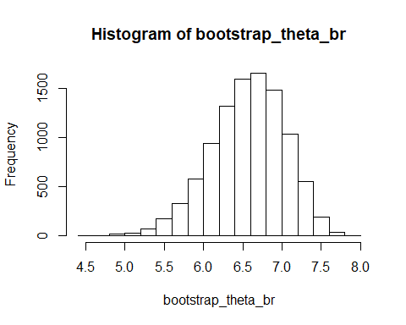

bootstrap_variance_br

## [1] 0.2191473

bootstrap_theta_CI_br

## [1] 5.647315 7.482358

bootstrap_theta_CI_br_pct

## [1] 5.562023 7.387759

We can see that the two confidence intervals are pretty close. ### Part b

# I'm not sure how to permute, so I'm just going to mix up the variables many many times and hope that's a good approximation  
combined = c(log_stomach,log_breast)  
itr = 100000  
test_statistic = NULL  
for(i in 1:itr){  
 sample = sample(combined)  
 permute_stomach = sample[1:13]  
 permute_breast = sample[14:24]  
 test_statistic[i] = mean(permute_stomach) - mean(permute_breast)  
}  
hist(test_statistic)

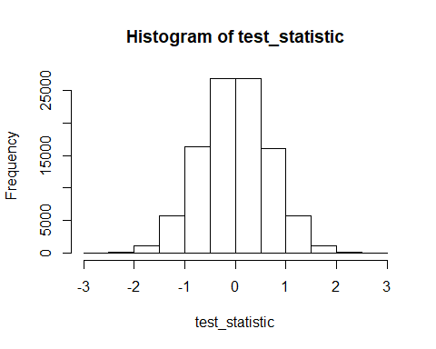

mean(test_statistic)

## [1] -0.00214056

boxplot(test_statistic)

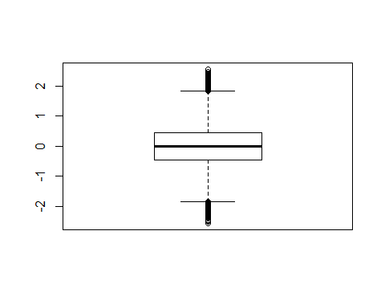 We can see that the different between the two groups is centered around 0. ### Part C

exp_breast_ci = exp(bootstrap_theta_CI_br_pct)  
b = 10000  
bootstrap_theta_orig = NULL  
for(i in 1:b){  
 n = length(breast)  
 data_bootstrap = sample(breast,size = n, replace = TRUE)  
 bootstrap_mean = mean(data_bootstrap)  
 bootstrap_theta_orig[i] = bootstrap_mean  
}  
bootstrap_theta_bar_orig = mean(bootstrap_theta_orig)  
bootstrap_variance_orig = 1/(b-1)*sum((bootstrap_theta_orig-bootstrap_theta_bar_orig)^2)  
hist(bootstrap_theta_orig)

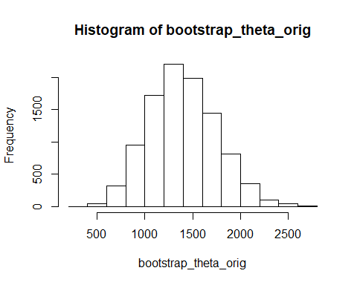

#Finding the CI using an alpha of .05 and using the Percentile Method  
sorted_bootstrap_theta_orig = sort(bootstrap_theta_orig)  
bootstrap_theta_CI_orig = c(bootstrap_theta_bar_orig- sqrt(bootstrap_variance_orig)*qnorm(.975),bootstrap_theta_bar_orig +sqrt(bootstrap_variance_orig)*qnorm(.975))  
bootstrap_theta_CI_orig_pct = c(sorted_bootstrap_theta_orig[round(b*.025)],sorted_bootstrap_theta_orig[round(b*.975)])  
exp_breast_ci

## [1] 260.349 1616.080

bootstrap_variance_orig

## [1] 126378.9

bootstrap_theta_CI_orig

## [1] 699.9172 2093.4441

bootstrap_theta_CI_orig_pct

## [1] 746.5455 2122.9091

We can see that the confidence intervals for the exponential confidence interval is a lot different from the one for just the original data.

## Problem 2

cauchy = rcauchy(1000)  
mean(cauchy)

## [1] -10.24537

b = 10000  
cauchy_bootstrap_means = NULL  
for(i in 1:b){  
 n = length(cauchy)  
 bootstrap_cauchy = sample(cauchy,size = n,replace = TRUE)  
 cauchy_bootstrap_means[i] = mean(bootstrap_cauchy)  
}  
hist(cauchy_bootstrap_means)

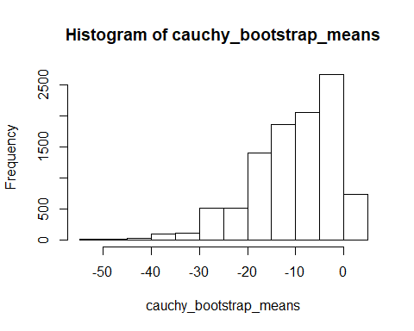

mean(cauchy_bootstrap_means)

## [1] -10.33495

#testing a smaller bootstrap  
cauchy = rcauchy(100)  
mean(cauchy)

## [1] -5.394489

b = 100  
cauchy_bootstrap_means = NULL  
for(i in 1:b){  
 n = length(cauchy)  
 bootstrap_cauchy = sample(cauchy,size = n,replace = TRUE)  
 cauchy_bootstrap_means[i] = mean(bootstrap_cauchy)  
}  
hist(cauchy_bootstrap_means)

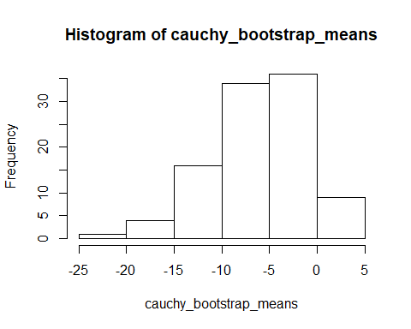

mean(cauchy_bootstrap_means)

## [1] -5.215819

# for estimating max  
uniform = runif(10000,0,2)  
max(uniform)

## [1] 1.99973

b = 10000  
uniform_boostrap_max = NULL  
for(i in 1:b){  
 n = length(uniform)  
 bootstrap_uniform = sample(uniform,size=n,replace= TRUE)  
 uniform_boostrap_max[i] = max(bootstrap_uniform)  
}  
hist(uniform_boostrap_max)

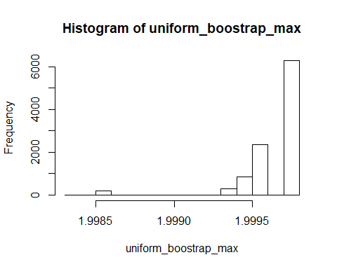

max(uniform_boostrap_max)

## [1] 1.99973

#testing a smaller bootstrap  
uniform = runif(10000,0,2)  
max(uniform)

## [1] 1.999659

b = 100  
uniform_boostrap_max = NULL  
for(i in 1:b){  
 n = length(uniform)  
 bootstrap_uniform = sample(uniform,size=n,replace= TRUE)  
 uniform_boostrap_max[i] = max(bootstrap_uniform)  
}  
hist(uniform_boostrap_max)

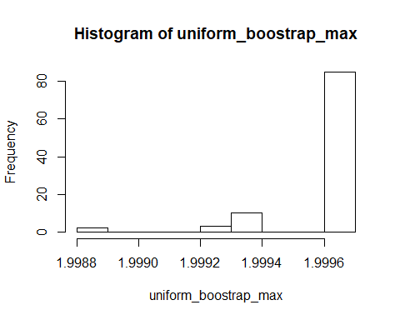

max(uniform_boostrap_max)

## [1] 1.999659

I’m honestly not too sure about this. I feel like they are predicting pretty accurately for the max and the mean of the cauchy. Maybe it’s because the histogram does not look centered around a single value, so that the variance of a small number of bootstraps could be very high?

## Problem 3

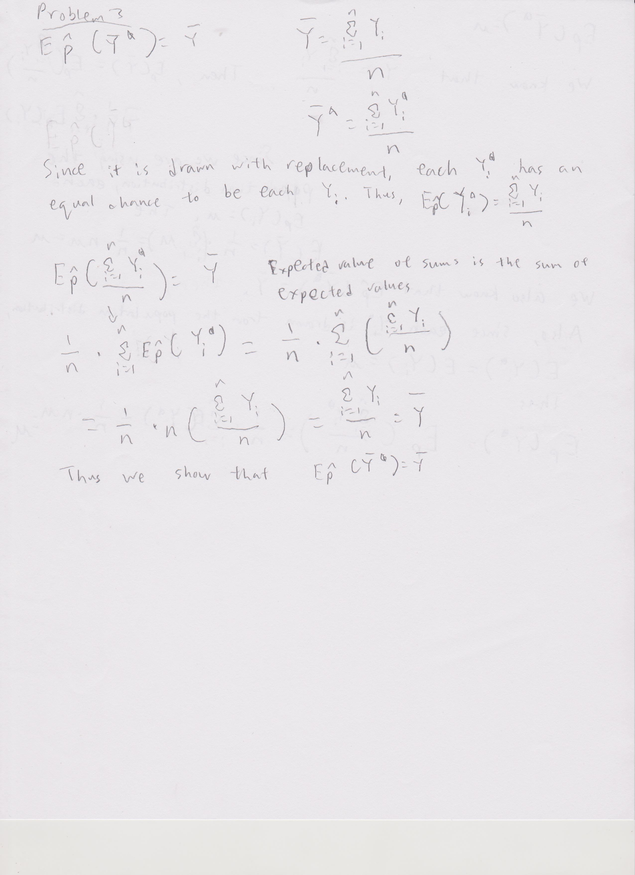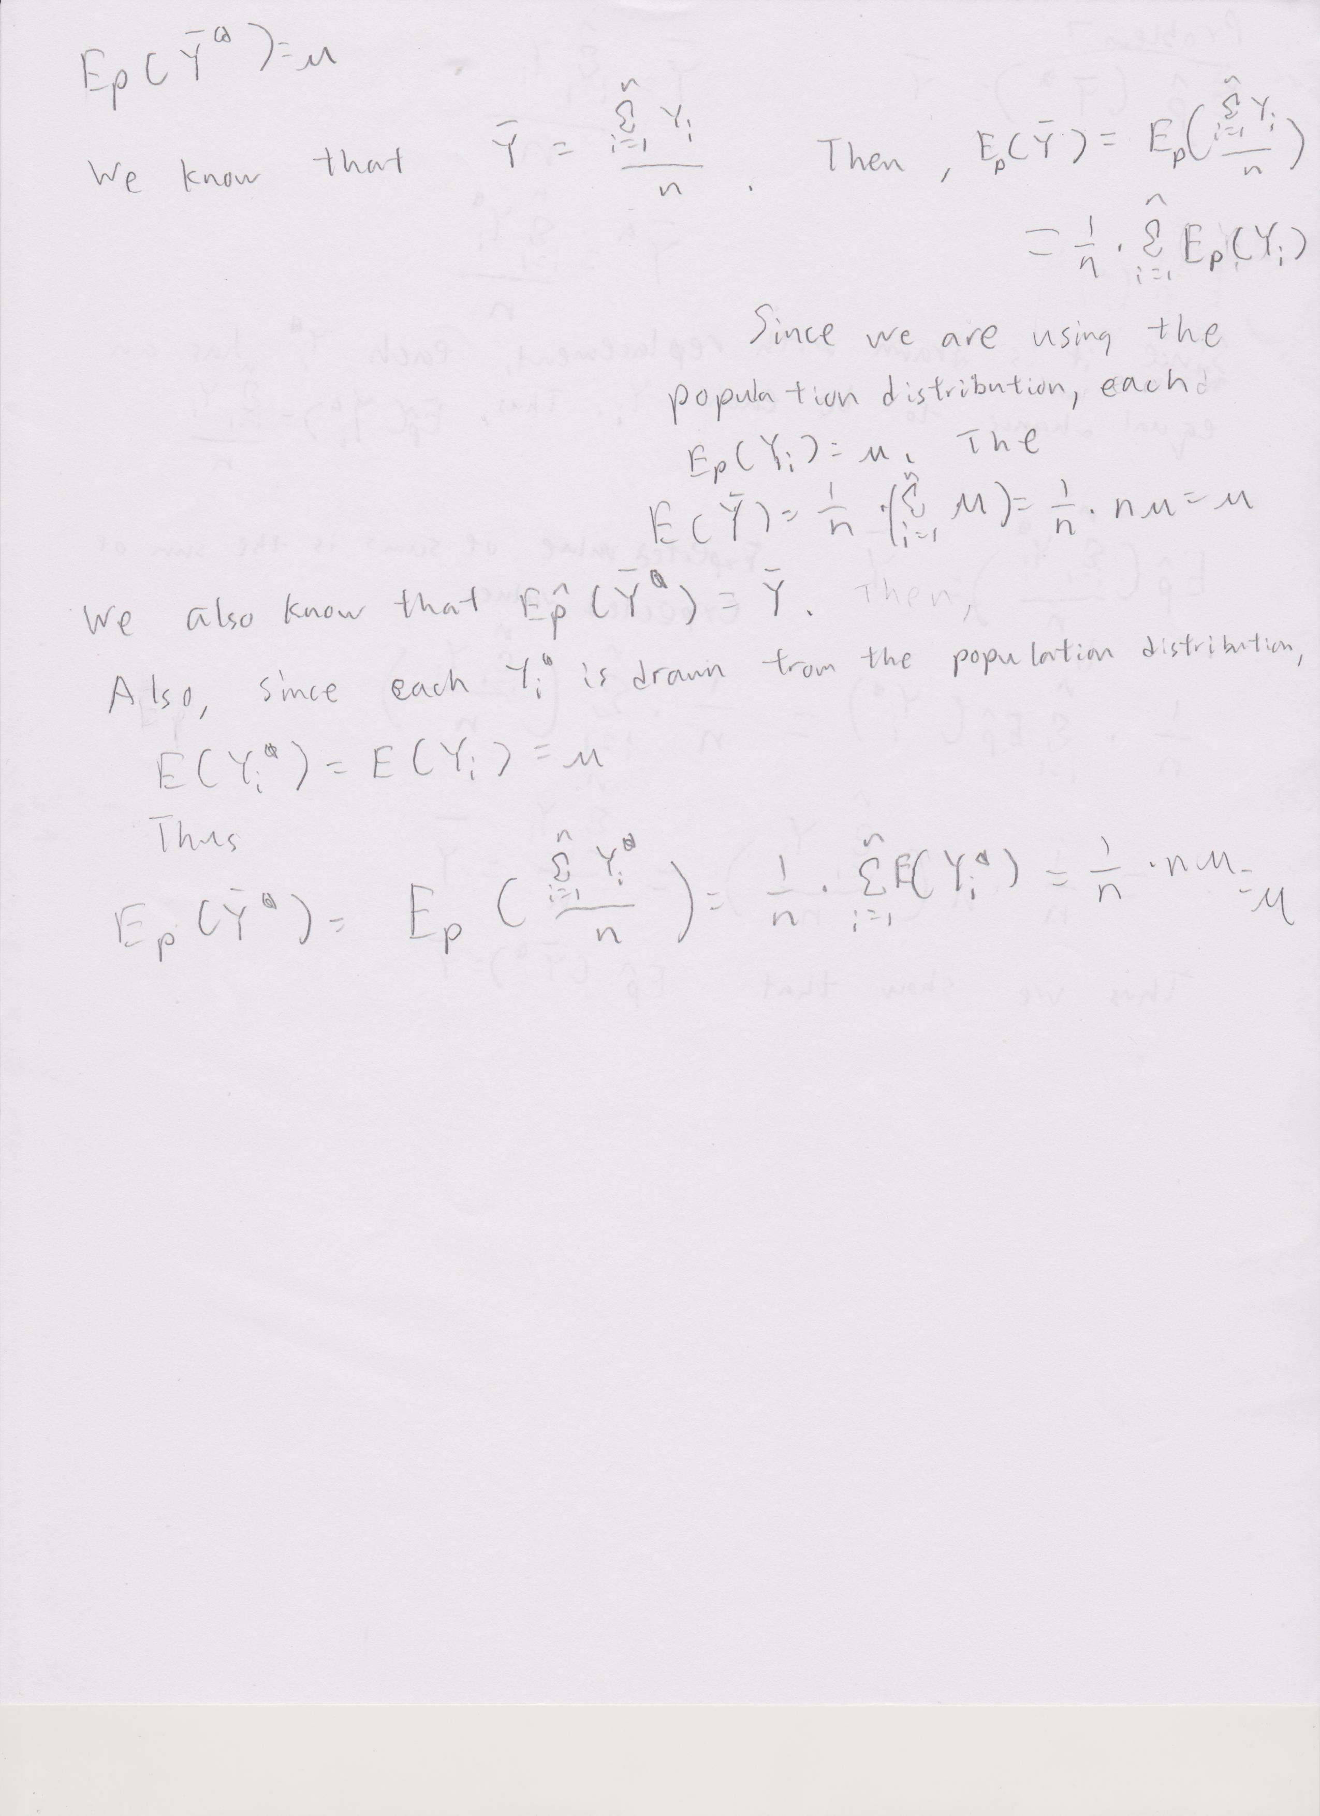

## Problem 4

p4_rnorm = rnorm(100,0,1)  
mean(p4_rnorm)

## [1] -0.1307336

##standard bootstrap  
b = 10  
p4_boot_mean = NULL  
for(i in 1:b){  
 n = length(p4_rnorm)  
 bootstrap_norm = sample(p4_rnorm,size=n,replace=TRUE)  
 p4_boot_mean[i] = mean(bootstrap_norm)  
}  
p4_theta_bar_star = mean(p4_boot_mean)  
bias_corrected = 2*mean(p4_rnorm) - mean(p4_boot_mean)  
p4_b_est_variance = 1/(b-1)*sum((p4_boot_mean - p4_theta_bar_star)^2)  
p4_theta_bar_star

## [1] -0.07590083

bias_corrected

## [1] -0.1855664

p4_b_est_variance

## [1] 0.007953236

##balanced bootstrap  
b=10  
balance_p4_rnorm = NULL  
for(i in 1:b){  
 balance_p4_rnorm = c(balance_p4_rnorm,p4_rnorm)  
}  
balance_p4_rnorm_permute = sample(balance_p4_rnorm, length(balance_p4_rnorm))  
balance_p4_means = NULL  
for(i in 1:b){  
 start = i*100 -99  
 end = i*100  
 balance_p4_means[i] = mean(balance_p4_rnorm_permute[start:end])  
}  
p4_balance_theta_bar_star = mean(balance_p4_means)  
balance_bias_corrected = 2*mean(p4_rnorm) - mean(balance_p4_means)  
p4_balance_variance = 1/(b-1)*sum((balance_p4_means-p4_balance_theta_bar_star)^2)  
mean(balance_p4_means)

## [1] -0.1307336

balance_bias_corrected

## [1] -0.1307336

p4_balance_variance

## [1] 0.005972435

We can see that the balanced bootstrap gave us an answer that was a lot closer to the real mean, with a smaller variance than the original bootstrap.